European Heritage Makers Week: #HeritageMakers to share their vision of Europe
European Heritage Makers Week aims to give voice to the youngest, encourage them to explore the history and heritage around them, and get involved in the European-level celebrations of #EuropeForCulture.

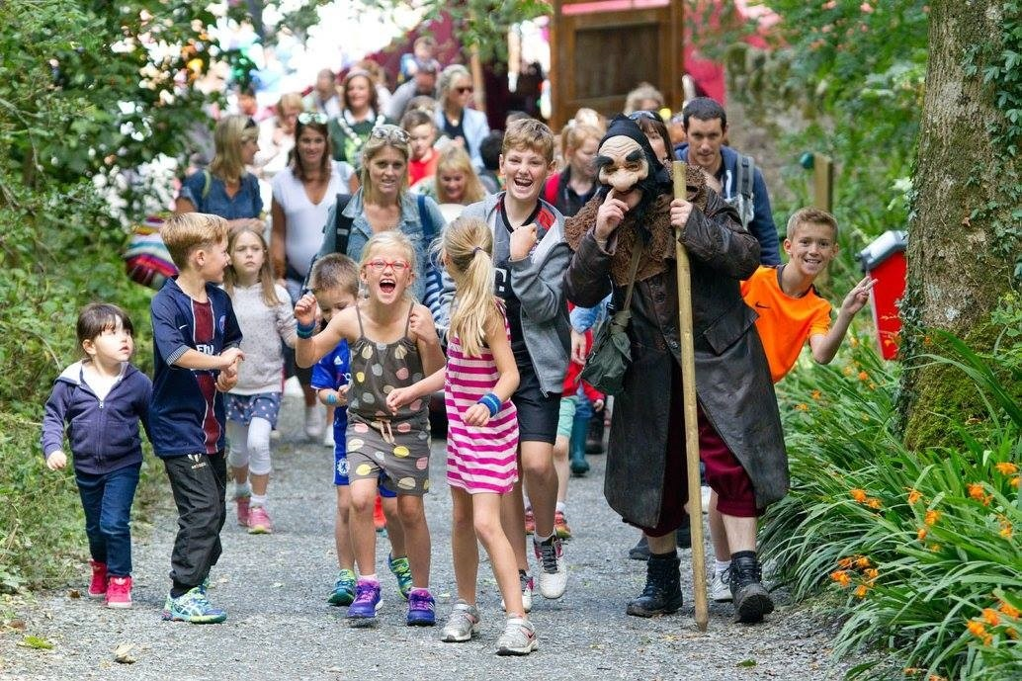
As a pilot initiative within European Heritage Days, European Heritage Makers Week aims to bring heritage closer to children and young people. Offering an opportunity for the youngest to actively explore their heritage and discover its beauty, it is one of the key initiatives to involve the next generation of #HeritageMakers. Through its cross-border scope, it also promotes European values, enabling young Europeans to connect through shared interests, and giving a greater visibility to local heritage.
On the occasion of celebrating Europe Day, the European Heritage Makers Week is set between 5th and 9th of May, and the stories of young #HeritageMakers are already being submitted. Launched on 18 April 2018, children and young people from participating countries are encouraged to explore their surroundings, get to know the cultural heritage around them and come up with a story of Europe in the selected site.
The stories can then be uploaded by their parents or legal guardians in the form of digital images (pictures, drawings, paintings, photographs, graphics, illustrations, and comics) to the EHD Portal with written stories alongside to give added insight. Following a national pre-selection, a European jury will select the ten most inspiring stories and invite #HeritageMakers to visit Strasbourg for a special event in November.
Further information and the rules for participation are available here: http://www.europeanheritagedays.com/European-Heritage-Makers-Week/.
Image: European Heritage Days in Ireland

Links and contact information

Organiser: European Heritage Days
Facebook: www.facebook.com/EHDays
Twitter: @JEP_EHD #EHDs
Instagram: @europeanheritagedays #EHDs #JEP

